Uber has been a major source of travel for people living in urban areas. Some people don’t have their vehicles while some don’t drive their vehicles intentionally because of their busy schedule. So different kinds of people are using the services of Uber and other taxi services. In this article, I will take you through Uber trips analysis using Python.

By analyzing Uber trips, we can draw many patterns like which day has the highest and the lowest trips or the busiest hour for Uber and many other patterns. The dataset I’m using here is based on Uber trips from New York, a city with a very complex transportation system with a large residential community.

The dataset contains data of about 4.5 million uber pickups in New York City from April to September and 14.3 million pickups from January to June 2015. You can do so much more with this dataset rather than just analyzing it. But for now, in the section below, I will take you through Uber Trips analysis using Python.

|  |
| --- |
|  |
|  |  |
|  |  |
|  |  |
|  |  |
|  | import pandas as pd import matplotlib as plt import seaborn as sns data = pd.read_csv("C:/Users/Dell/Desktop/dataanalyst/Uber.csv") data["Date/Time"] = data["Date/Time"].map(pd.to_datetime) print(data.head()) |

Here we import libraries which are usefull for our task

And then we had read our csv file

Pd.to_datetime helps to convert date time string to object

And then printing our data top 5 rows by using head()

Date/Time Lat Lon Base

0 2014-09-01 00:01:00 40.2201 -74.0021 B02512

1 2014-09-01 00:01:00 40.7500 -74.0027 B02512

2 2014-09-01 00:03:00 40.7559 -73.9864 B02512

3 2014-09-01 00:06:00 40.7450 -73.9889 B02512

4 2014-09-01 00:11:00 40.8145 -73.9444 B02512

This is the output

|  |
| --- |
|  |
|  |  |
|  |  |
|  |  |

data["Day"] = data["Date/Time"].apply(lambda x: x.day)  
data["Weekday"] = data["Date/Time"].apply(lambda x: x.weekday())  
data["Hour"] = data["Date/Time"].apply(lambda x: x.hour)  
print(data.head())

Here we have used Lambda expression and we had got day weekday hour columns.

0 2014-09-01 00:01:00 40.2201 -74.0021 B02512 1 0 0

1 2014-09-01 00:01:00 40.7500 -74.0027 B02512 1 0 0

2 2014-09-01 00:03:00 40.7559 -73.9864 B02512 1 0 0

3 2014-09-01 00:06:00 40.7450 -73.9889 B02512 1 0 0

4 2014-09-01 00:11:00 40.8145 -73.9444 B02512 1 0 0

This is the output.

So I have prepared this data according to the days and hours, as I am using the Uber trips for the September month so let’s have a look at each day to see on which day the Uber trips were highest:

sns.set(rc={'figure.figsize':(12, 10)})  
sns.distplot(data["Day"])  
plt.show()

import matplotlib.pyplot as plt

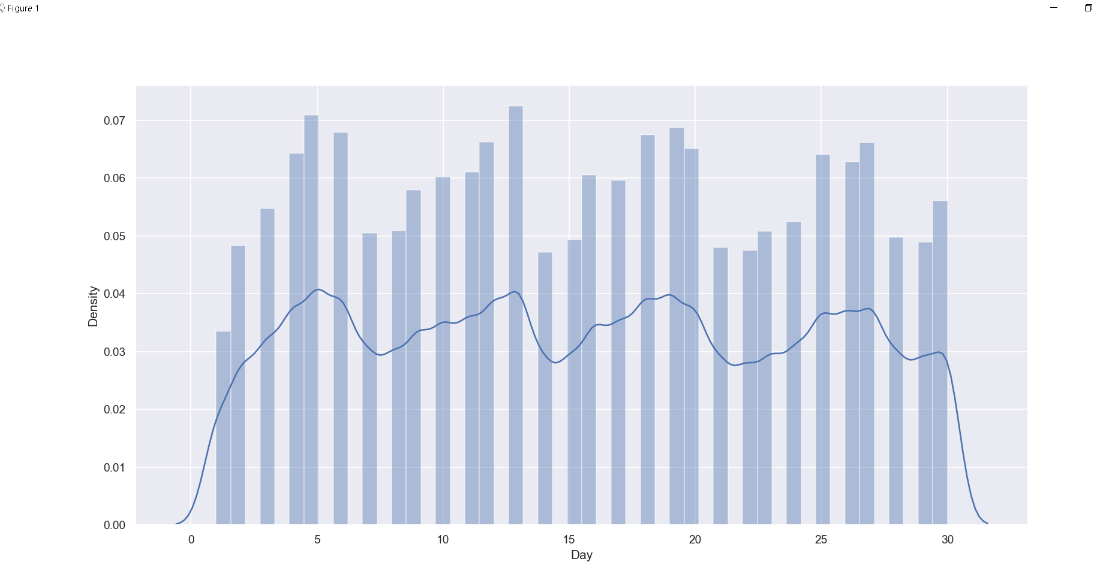

By looking at the daily trips we can say that the Uber trips are rising on the working days and decreases on the weekends. Now let’s analyze the Uber trips according to the hours:

sns.set(rc={'figure.figsize':(12, 10)})  
sns.distplot(data["Hour"])  
plt.show()

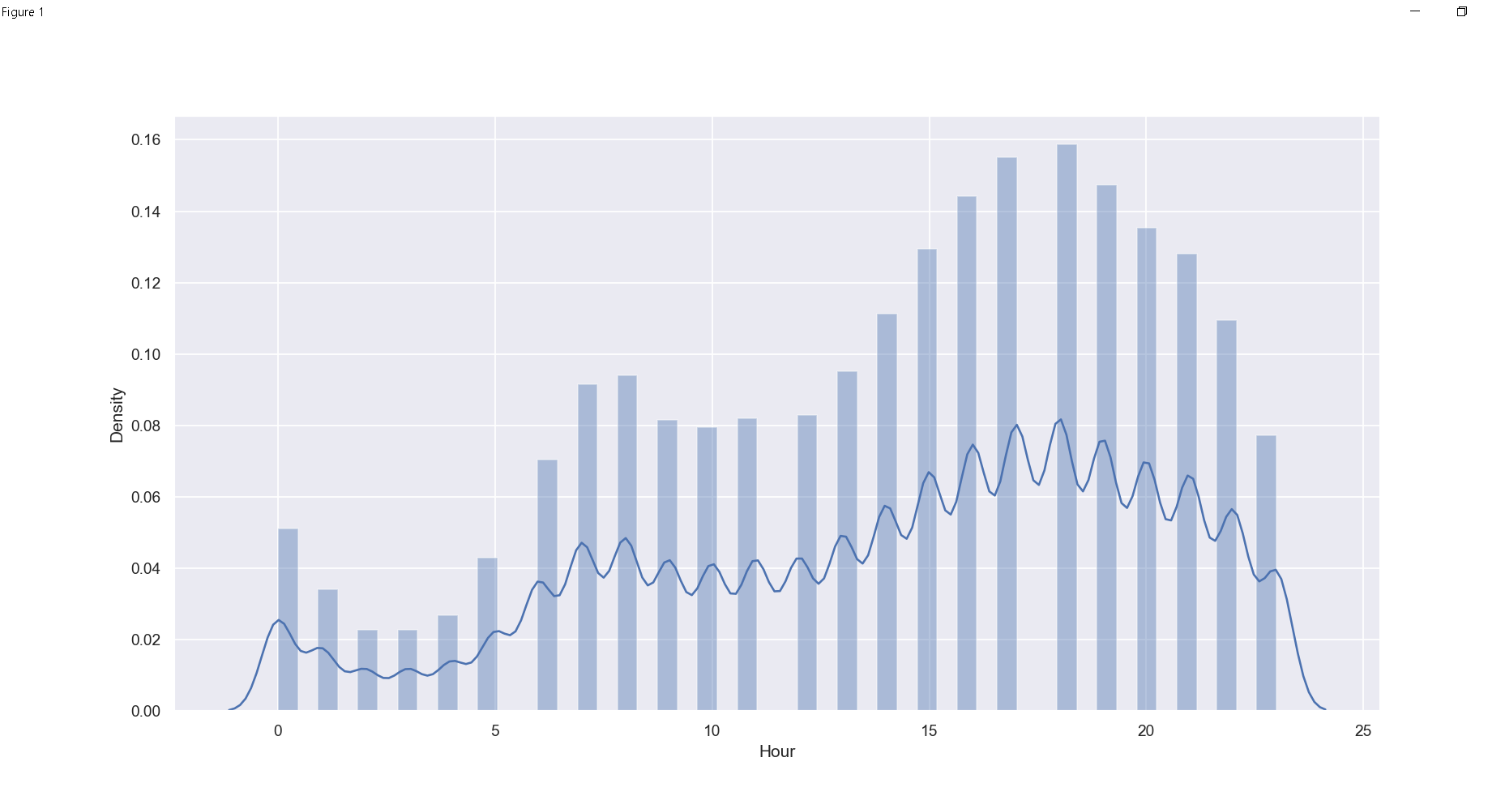

According to the hourly data, the Uber trips decreases after midnight and then start increasing after 5 am and the trips keep rising till 6 pm such that 6 pm is the busiest hour for Uber then the trips start decreasing. Now let’s analyze the Uber trips according to the weekdays:

sns.distplot(data["Weekday"])

sns.set(rc={'figure.figsize':(12, 10)})  
sns.distplot(data["Weekday"])  
plt.show()

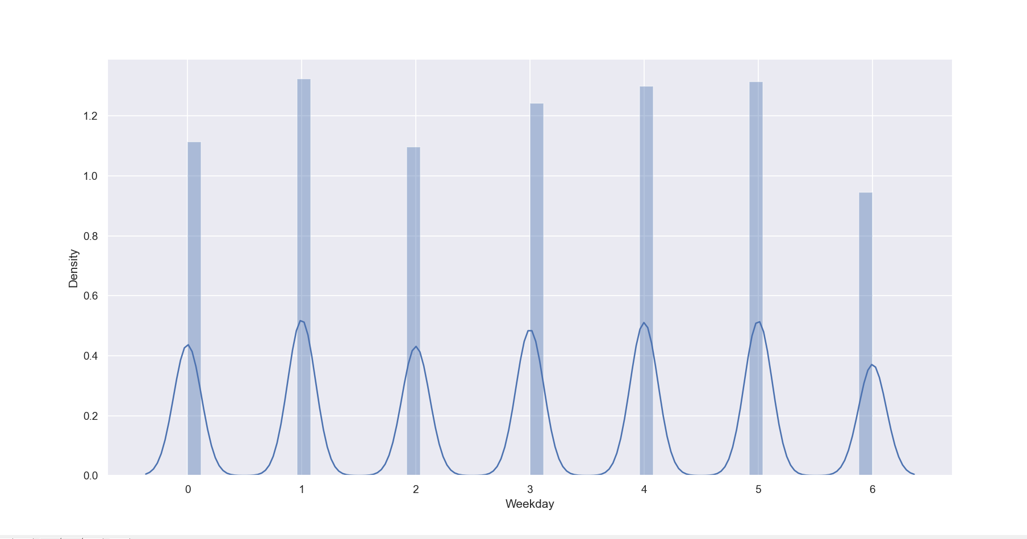

In the above figure 0 indicates Sunday, on Sundays the Uber trips and more than Saturdays so we can say people also use Uber for outings rather than for just going to work. On Saturdays, the Uber trips are the lowest and on Mondays, they are the highest. Now let’s have a look at the [***correlation***](https://thecleverprogrammer.com/2021/02/11/pearson-correlation-using-python/) of hours and weekdays on the Uber trips:

df = data.groupby(["Weekday", "Hour"]).apply(lambda x: len(x))  
df = df.unstack()  
sns.heatmap(df, annot=False)  
plt.show()

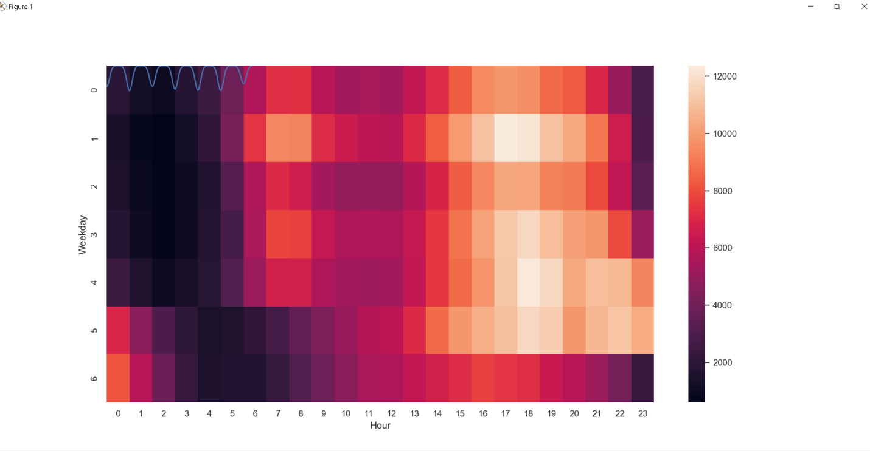

As we are having the data about longitude and latitude so we can also plot the density of Uber trips according to the regions of the New Your city:

|  |
| --- |
|  |
|  | data.plot(kind='scatter', x='Lon', y='Lat', alpha=0.4, s=data['Day'], label='Uber Trips', figsize=(12, 8), cmap=plt.get_cmap('jet')) plt.title("Uber Trips Analysis") plt.legend() plt.show() |
|  |  |
|  |  |
|  |  |

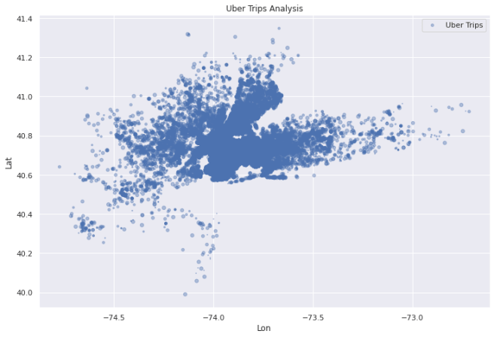

**Summary**

So this is how we can analyze the Uber trips for New York City. Some of the conclusions that I got from this analysis are:

1. Monday is the most profitable day for Uber
2. On Saturdays less number of people use Uber
3. 6 pm is the busiest day for Uber
4. On average a rise in Uber trips start around 5 am.
5. Most of the Uber trips originate near the Manhattan region in New York.